Design – Sequence Diagrams

A report describing the Sequence Diagrams for the Network Appliance Service Utilisation Framework

Version: 0.1

By

Paul Fergus

Supervised by

Dr. Martin Hanneghan and Prof. Madjid Merabti

Networked Appliances Lab
School of Computing and Mathematical Sciences
Liverpool John Moores University

Table of Contents
Table of Contents ii
Table of Figures vii
1 Introduction 2
1.1 Sections 2
1.2 Release Information 2
1.3 Reader Level 2
1.4 The Specification Process 2
1.5 Version Information 3
1.6 Referenced Documents 3
2 Sequence Diagram: Start Device 4
2.1 Description 4
2.2 Issues 4
2.3 Requirements Error! Bookmark not defined.
2.4 Goals/Context Error! Bookmark not defined.
2.5 Assumptions 4
2.6 Scenario/Steps 4
2.7 Extensions 4
3 Sequence Diagram: Connect Device to the Network 6
3.1 Description 6
3.2 Issues 6
3.3 Requirements Error! Bookmark not defined.
3.4 Goals/Context Error! Bookmark not defined.
3.5 Assumptions 6
3.6 Scenario/Steps 6
3.7 Extensions 7
4 Sequence Diagram: Create Device Capability Advertisement 8
4.1 Description 8
4.2 Issues 8
4.3 Requirements Error! Bookmark not defined.
4.4 Goals/Context Error! Bookmark not defined.
4.5 Assumptions 8
4.6 Scenario/Steps 8
4.7 Extensions 9
5 Sequence Diagram: Publish Device Capability Advertisement 10
5.1 Description 10
5.2 Issues 10
5.3 Requirements Error! Bookmark not defined.
5.4 Goals/Context Error! Bookmark not defined.
5.5 Assumptions 10
5.6 Scenario/Steps 10
5.7 Extensions 10
6 Sequence Diagram: Publish Implementation Services 11
6.1 Description 11
6.2 Issues 11
6.3 Requirements Error! Bookmark not defined.
6.4 Goals/Context Error! Bookmark not defined.
6.5 Assumptions 11
6.6 Scenario/Steps 11
6.7 Extensions 12
7 Sequence Diagram: Create Peer Service Advertisement 13
7.1 Description 13
7.2 Issues 13
7.3 Requirements Error! Bookmark not defined.
7.4 Goals/Context Error! Bookmark not defined.
7.5 Assumptions 13
7.6 Scenario/Steps 14
7.7 Extensions 14
8 Sequence Diagram: Publish Peer Services 15
8.1 Description 15
8.2 Issues 15
8.3 Requirements Error! Bookmark not defined.
8.4 Goals/Context Error! Bookmark not defined.
8.5 Assumptions 15
8.6 Scenario/Steps 15
8.7 Extensions 15
9 Sequence Diagram: Create Semantic Models 16
9.1 Description 16
9.2 Issues 16
9.3 Requirements Error! Bookmark not defined.
9.4 Goals/Context Error! Bookmark not defined.
9.5 Assumptions 17
9.6 Scenario/Steps 17
9.7 Extensions 17
10 Sequence Diagram: Find Core Services 18
10.1 Description 18
10.2 Issues 18
10.3 Requirements Error! Bookmark not defined.
10.4 Goals/Context Error! Bookmark not defined.
10.5 Assumptions 18
10.6 Scenario/Steps 18
10.7 Extensions 18
11 Sequence Diagram: Realise Context Templates 19
11.1 Description 19
11.2 Issues 19
11.3 Requirements Error! Bookmark not defined.
11.4 Goals/Context Error! Bookmark not defined.
11.5 Assumptions 19
11.6 Scenario/Steps 19
11.7 Extensions 20
12 Sequence Diagram: Discover Peer Services 21
12.1 Description 21
12.2 Issues 21
12.3 Requirements Error! Bookmark not defined.
12.4 Goals/Context Error! Bookmark not defined.
12.5 Assumptions 21
12.6 Scenario/Steps 21
12.7 Extensions 21
13 Sequence Diagram: Invoke Peer Service 22
13.1 Description 22
13.2 Issues 22
13.3 Requirements Error! Bookmark not defined.
13.4 Goals/Context Error! Bookmark not defined.
13.5 Assumptions 22
13.6 Scenario/Steps 22
13.7 Extensions 22
14 Sequence Diagram: Process Service Request 23
14.1 Description 23
14.2 Issues 23
14.3 Requirements Error! Bookmark not defined.
14.4 Goals/Context Error! Bookmark not defined.
14.5 Assumptions 23
14.6 Scenario/Steps 23
14.7 Extensions 24
15 Sequence Diagram: Get Concept 24
15.1 Description 25
15.2 Issues 25
15.3 Requirements Error! Bookmark not defined.
15.4 Goals/Context Error! Bookmark not defined.
15.5 Assumptions 25
15.6 Scenario/Steps 25
15.7 Extensions 25
16 Sequence Diagram: Evolve Concept 26
16.1 Description 26
16.2 Issues 26
16.3 Requirements 26
16.4 Goals/Context 26
16.5 Assumptions 26
16.6 Scenario/Steps 26
16.7 Extensions 26
17 Sequence Diagram: Perform Abstract Match 27
17.1 Description 27
17.2 Issues 27
17.3 Requirements 27
17.4 Goals/Context 27
17.5 Assumptions 27
17.6 Scenario/Steps 28
17.7 Extensions 28
18 Sequence Diagram: Perform Concrete Match 29
18.1 Description 29
18.2 Issues 29
18.3 Requirements 29
18.4 Goals/Context 29
18.5 Assumptions 29
18.6 Scenario/Steps 30
18.7 Extensions 30
19 Sequence Diagram: Build Signature 31
19.1 Description 31
19.2 Issues 31
19.3 Requirements 31
19.4 Goals/Context 32
19.5 Assumptions 32
19.6 Scenario/Steps 32
19.7 Extensions 32
20 Sequence Diagram: Find Intermediary Service 33
20.1 Description 33
20.2 Issues 33
20.3 Requirements 33
20.4 Goals/Context 33
20.5 Assumptions 34
20.6 Scenario/Steps 34
20.7 Extensions 34
21 References 35

Table of Figures
Figure 1 Start Device 4
Figure 2 Connect Device to the Network 6
Figure 3 Create Device Capability Advertisement 8
Figure 4 Publish Device Capability Advertisement 10
Figure 5 Publish Implementation Services 11
Figure 6 Create Peer Service Advertisement 13
Figure 7 Publish Services 15
Figure 8 Create Semantic Models 16
Figure 9 Find Core Services 18
Figure 10 Realise Context Templates 19
Figure 11 Discover Peer Services 21
Figure 12 Invoke Peer Service 22
Figure 13 Process Service Request 23
Figure 14 Get Concept 25
Figure 15 Evolve Concept 26
Figure 16 Perform Abstract Match 27
Figure 17 Perform Concrete Match 29
Figure 18 Build Signature 31
Figure 19 Find Intermediary Service 33

ABSTRACT
User demands and technological advances are driving the complex integration between heterogeneous devices, and moving us closer to pervasive and ubiquitous computing environments. The home of the future will include an embedded ‘intelligence’ and accommodate a flexible integration of services to perform functions that are only limited by our imagination. The family car and working environment will be closely integrated allowing the children to watch a movie on digital screens embedded in the back of the driver and passenger seats, by directly streaming the digital content from the DVD player located in the living room of your home. Furthermore you will be able to access and listen to music stored on your MP3 player, which you accordingly left at the office on Friday night, via your wireless enabled headphones, without interrupting the children’s viewing experience. This vision will expose the functionalities offered by devices as independent services [1] and capitalise on advances made in global communications to revolutionise the way we interact with the plethora of devices that surround us.
This vision will require us to perceive and interact with our devices in ways we have never experienced before. The constraints placed on us by manufacturers and service providers will become a thing of the past as the flexible and seamless integration of distributed devices become common place. One of the challenges is to expose the functions offered by devices as services. Manufactures will need to re-engineer most common household appliances and produce solutions that better utilise the functionalities a particular device offers. A framework needs to be developed that allows services to be described using machine-processible semantics enabling devices to make informed decisions regarding the composition process once a potential service has been discovered. The framework needs to utilise advances made in Peer-to-Peer technologies and provide discovery mechanisms that ensure collaborations between devices encompass vocabularies that support machine-level understanding.
In this report we describe how we have designed the Networked Appliance Service Utilisation Framework (NASUF) including the Distributed Semantic Unstructured Services (DiSUS) [2] protocol, the Distributed Emergent Semantics (DistrES) algorithm [3] and the Semantic Interoperability and Signature Matching (SISM) algorithms [4]. We explain how NASUF implements the DiSUS protocol to publish and discover unstructured services within P2P networks, the DistrES algorithm to manage and evolve ontological information over time based on general consensus, and the SISM algorithm to dynamically compose services and resolve terminology differences that occur.

Introduction
The Network Appliance Service Utilisation Framework (NASUF) is designed to allow service-enabled devices to be seamlessly integrated within Peer-to-Peer (P2P) networks. Once these devices have been deployed they can expose the functions they provide as independent services, which are described and discovered using machine-processable semantics.
The framework is flexible and does not place any constraints on the underlying technologies used. It is designed to provide a set of core interfaces that must be implemented in order to enable services to be effectively described and discovered within P2P networks. This framework does not place any constraints on the underlying communication protocols used or the P2P technology used to deploy devices and the services they provide. Furthermore it does not place any constraints on the service technology used allowing a plethora of different services to be used and integrated with relative ease.
This is the first release of this specification and is still a work in progress. Its primary goal is to define a set of generic interfaces that support the above mentioned requirements.

Sections
There is only one section in this document, which describes the vocabulary used and provides a detailed list of all the Sequence Diagrams used to define this framework.

Release Information
This document is a work in progress and is an initial first draft. This release is an unstable release that is designed to prompt discussions in order to refine our overall framework design. Its primary function is to highlight the functionalities this framework provides and to prompt further investigation.

Reader Level
This document can be used by a number of readers, who are concerned with the framework from a number of different viewpoints.
- Service Developers
- Distributed Computing Developers
- Semantic Web Developers
- Networked Appliance Developers
- Framework Designers
- Enterprise Architects
This specification assumes that the reader is converse with UML and more specifically Sequence Diagram design. The specification is language and protocol agnostic and could be used to implement service-enabled networked appliances using a number of different languages, which implement a number of different communication protocols.

The Specification Process
The specification process is performed as part of a PhD project, with a number of researchers and Academic staff involved in its creation. The specification is reviewed subject matter experts within the fields of UML modelling, P2P technologies, Semantic Web technologies and Networked Appliances. We hope that as this specification evolves it will be opened up to a much wider audience, whereby contributions can be made by a number of expert groups.
The current process involves the framework design using a number of UML models. At predetermined millstones the designs are submitted to the subject matter experts, which are then evaluated. Any changes are performed and all design decisions are challenged. This process continues until defined work packages are completed.

Version Information
This version is not designed to be used for implementations. This version is designed to prompt discussion on this framework design to ensure that the framework captures all the required functionality.

Referenced Documents
The following documents should be read in conjunction with this Class Diagram document.
- NASUF – Use Case Diagram 1.0.doc
- NASUF – Activity Diagram 1.0.doc
- NASUF – Class Diagram 1.0.doc

Sequence Diagram: Start Device

Description
This Sequence Diagram illustrates what happens when the device is started within this framework. The Sequence Diagram is illustrated in Figure 1.
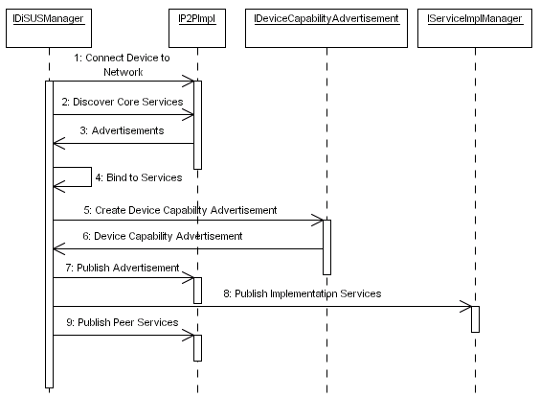
Figure 1 Start Device

Issues
The issues associated with the Sequence Diagram are not known at this stage.

Assumptions
The assumptions for this Sequence Diagram are not known at this stage of the design

Scenario/Steps
The DiSUS Manger begins be connecting the device to the P2P implementation. Once the device has been connected the DiSUS Manager discovers all the Core Services used within the framework using the P2P implementation – these Core Services may be provided by the device itself or remotely by other devices within the P2P network. Once the core services have been discovered the DiSUS Manager binds to the endpoint of each one. The DiSUS Manager then creates the device capability advertisement and publishes it locally and remotely within the P2P network using the P2P implementation. The DiSUS Manager then publishes all the implementation services using the Service Implementation Manager. Once the implementation services have been published the DiSUS Manager publishes all the Application Specific Peer Services.

Extensions
The framework provides a level of flexibility that allows peer services to form an abstraction that maps to any implementation service technology the device manufacturer or organisation uses. However there may be instances whereby only the peer service can be used. For example such service technologies as Web Services and RMI are transactional and although this may not pose a problem in some situations it may in others – one example may be streaming large amounts of video and audio data. In this instance the action is not transactional – data streams need to be opened and maintained whilst the data is being transferred or broadcasted. Therefore it may be easier to stream the data directly to a peer service without using a secondary implementation services. This scenario is not set in concrete and device manufacturers may decide to stream data to an implementation service via a peer service in order to maintain the level of abstraction.

Sequence Diagram: Connect Device to the Network

Description
This Sequence Diagram illustrates what happens when the device is connected to the network within this framework. The Sequence Diagram is illustrated in Figure 2.
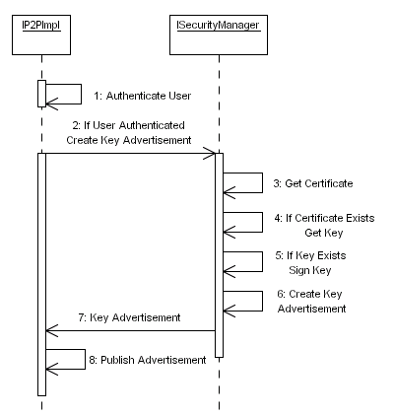
Figure 2 Connect Device to the Network

Issues
The issues associated with the Sequence Diagram are not known at this stage.

Assumptions
Within this Activity Diagram the framework does not place any constraints on how the device authenticates itself within the network. We envisage that this will be different for each application and will depend on the device manufacturer’s security policy. Again the framework does not place any constrains on how certificates or private/public keys are obtained.

Scenario/Steps
When the DiSUS Manager attempts to connect the device to the network the P2P implementation begins by authenticating the user (device). How this is achieved is dependent on the P2P implementation being used. If the device is successfully authenticated the P2P implementation uses the Security Manager to create a Public Key Advertisement. The Security Manager first retrieves a certificate from the devices persistent storage. If the certificate exists the Security Manager retrieves the Public Key from the devices persistent storage. If the key exists it is digitally signed using the certificate before it is inserted into a Key Advertisement, which is then returned to the P2P Implementation object. Once the P2P implementation object receives the key advertisement it is published locally and remotely within the P2P network.

Extensions
No extensions to the details defined above are known at this stage.

Sequence Diagram: Create Device Capability Advertisement

Description
This Sequence Diagram illustrates how device capability advertisements are created within this framework. The Sequence Diagram is illustrated in Figure 3.
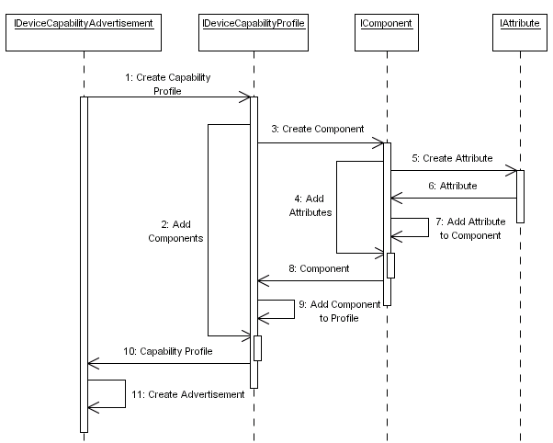
Figure 3 Create Device Capability Advertisement

Issues
The issues associated with the Sequence Diagram are not known at this stage.

Assumptions
It is the device manufacturers’ responsibility to ensure that the capability descriptions conform to some specification – for example if CC/PP [5] is used then the device manufacturer must ensure that the capability descriptions are valid CC/PP descriptions. The minimum requirement is that the device capability advertisement must be serialised to a RDF(S)-based format. We do not place any constraints on the vocabulary used to describe the individual capability descriptions as the semantic interoperability mechanism implemented in this framework will resolve terms that are syntactically distinct but semantically equivalent.

Scenario/Steps
When the DiSUS Manager creates a Device Capability Advertisement the sequence begins by first creating a Device Capability Profile object. When a Profile is created an iterative process is used to create all the required components used. In turn each component object enters an iterative process that creates and adds all the required attributes associated with a particular component. When all the attributes have been added to the component, the component is added to the profile. When all the components have been added the Capability Profile is returned to the Device Capability Advertisement object. This profile is appended to the advertisement, which is returned to the DiSUS Manager.

Extensions
No extensions to the details defined above are known at this stage.

Sequence Diagram: Publish Device Capability Advertisement

Description
This Sequence Diagram illustrates what happens when the device is connected to the network. It illustrates how the device connects to the network, publishes its capabilities and publishes the services it provides. The Sequence Diagram is illustrated in Figure 4.
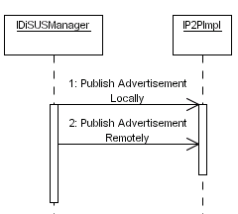
Figure 4 Publish Device Capability Advertisement

Issues
The issues associated with the Sequence Diagram are not known at this stage.

Assumptions
The assumptions for this Sequence Diagram are not known at this stage of the design

Scenario/Steps
When a Device Capability Advertisement has been created it must be published locally and remotely within the P2P network.

Extensions
No extensions to the details defined above are known at this stage.

Sequence Diagram: Publish Implementation Services

Description
This Sequence Diagram illustrates what happens when peer service advertisements are created. It illustrates how the device connects to the network, publishes its capabilities and publishes the services it provides. The Sequence Diagram is illustrated in Figure 6.
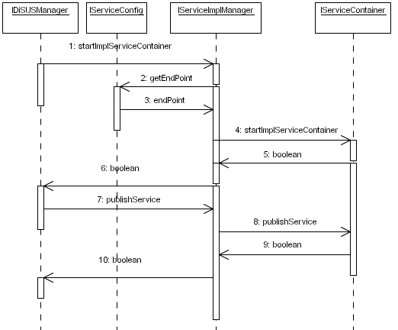
Figure 5 Publish Implementation Services

Issues
The issues associated with the Sequence Diagram are not known at this stage.

Assumptions
We have assumed that implementation services are objects, which are published within service containers such as GLUE, Tomcat or Jini. This allows services to be contained within some environment that allows them to be addressed discovered and invoked. This may not be the case and some other service mechanism may be used – what service technology being used is left to the device manufacturer to decide.

Scenario/Steps
Before implementation services are published the DiSUS Manager starts the service container. The Service Implementation Manager first obtains the endpoint that must be used to locate the services published by the Service Container. What form the endpoint takes is dependent on the service technology being used. This endpoint is used to start the Service Container. Once the Service Container has been started each of the Implementation Services is published.

Extensions
No extensions to the details defined above are known at this stage.

Sequence Diagram: Create Peer Service Advertisement

Description
This Sequence Diagram illustrates what happens when peer service advertisements are created. It illustrates how the device connects to the network, publishes its capabilities and publishes the services it provides. The Sequence Diagram is illustrated in Figure 6.
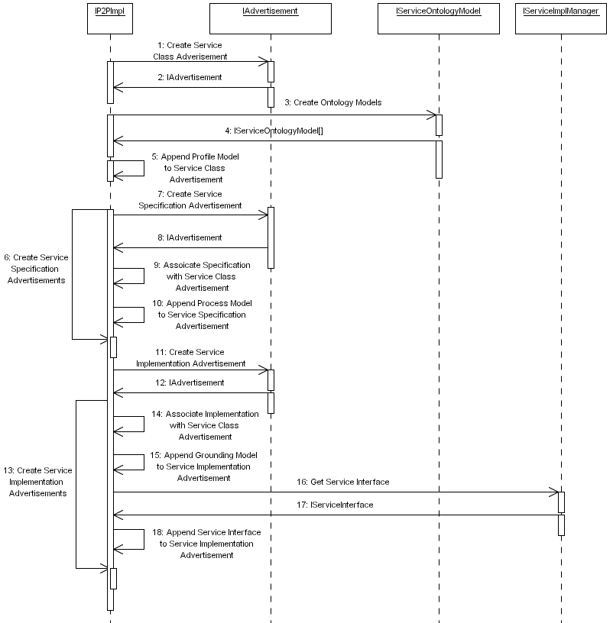
Figure 6 Create Peer Service Advertisement

Issues
The issues associated with the Sequence Diagram are not known at this stage.

Assumptions
This Activity Diagram assumes that service advertisements are described using an RDF(S) based ontology language. This is the base requirement, however we assume that more expressive ontology languages will be used such as DAML+OIL or OWL - this decision is left to the device manufacturer.

Scenario/Steps
The P2P Implementation publishes peer services provided by the device and as such each peer service must be described and advertised. The P2P implementation begins by creating a Class Advertisement. Once the Class Advertisement has been created the P2P implementation creates the service ontology models. The Service Profile is retrieved from the service ontology model collection and appended to the Service Class Advertisement. Once this is complete the P2P implementation creates a Service Specification Advertisement, associates it with the Service Class Advertisement using the Service Class UUID and appends the Service Process Model to the Service Specification Advertisement. This is an iterative process as a peer service may have several Service Specification Advertisements. Once all the Service Specification Advertisements have been created the P2P implementation creates a Service Implementation Advertisement, associates it with the Service Class Advertisement using the Service Class UUID and appends the Service Grounding Model to the Service Implementation Advertisement. The P2P implementation also retrieves the service interface from the Service Implementation Manager and appends it to the Service Implementation Advertisement. This is an iterative process as a peer service may have several Service Implementation Advertisements.

Extensions
No extensions to the details defined above are known at this stage.

Sequence Diagram: Publish Peer Services

Description
This Sequence Diagram illustrates what happens when the device publishes the services it provides. It illustrates how the device connects to the network, publishes its capabilities and publishes the services it provides. The Sequence Diagram is illustrated in Figure 7.
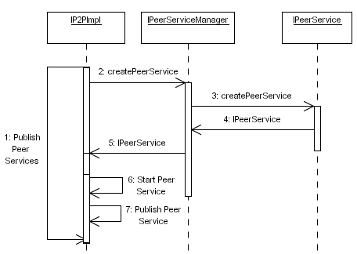
Figure 7 Publish Services

Issues
The issues associated with the Sequence Diagram are not known at this stage.

Assumptions
The assumptions for this Sequence Diagram are not known at this stage of the design

Scenario/Steps
Devices will support zero or more Peer Services that expose the core functionality the framework provides including application specific functionality. The P2P implementation begins by creating a Peer Service using the Peer Service Manager. Once the Peer Service has been created and returned to the P2P Implementation it starts the service listening on some specified endpoint. When the service has been started the P2P Implementation publishes the peer service advertisements so that the service can be discovered and used by other devices within the P2P network.

Extensions
No extensions to the details defined above are known at this stage.

Sequence Diagram: Create Semantic Models

Description
This Sequence Diagram illustrates what happens when the device publishes the services it provides. It illustrates how the device connects to the network, publishes its capabilities and publishes the services it provides. The Sequence Diagram is illustrated in Figure 8.
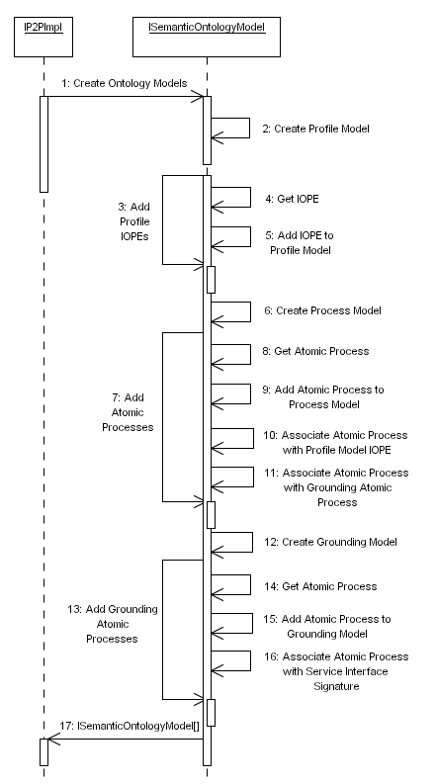
Figure 8 Create Semantic Models

Issues
The issues associated with the Sequence Diagram are not known at this stage.

Assumptions
The assumptions for this Sequence Diagram are not known at this stage of the design

Scenario/Steps
The P2P Implementation object creates the Service Ontology Models, which describe Peer Services in terms of their capabilities. The P2P Implementation begins by using the Semantic Ontology Model object to create a Profile Model. Once this model has been created all the IOPEs used to describe the service are added to the Service Profile. Once all the IOPEs have been added the Service Ontology model creates the Service Process Model. Once the model has been created all the Process Atomic Processes are added to the model and associated with IOPEs in the Service Profile Model and Atomic Processes in the Service Grounding Model. Once the all the Atomic Processes have been added the Service Grounding Model is created and again all the Grounding Atomic Processes are added to the model. Each Grounding Atomic Process that is added is associated with a signature in the Service Interface. When all the Grounding Atomic Processes have been added to the model all the ontology models are returned to the P2P Implementation. These models are then appended to the relevant Service Advertisements.

Extensions
No extensions to the details defined above are known at this stage.

Sequence Diagram: Find Core Services

Description
This Sequence Diagram illustrates what happens when the device publishes the services it provides. It illustrates how the device connects to the network, publishes its capabilities and publishes the services it provides. The Sequence Diagram is illustrated in Figure 9.
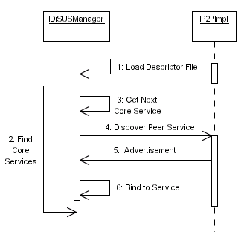
Figure 9 Find Core Services

Issues
The issues associated with the Sequence Diagram are not known at this stage.

Assumptions
The assumptions for this Sequence Diagram are not known at this stage of the design

Scenario/Steps
The DiSUS Manager begins by loading a descriptor file that describes all the core services required within this framework. Each entry in the descriptor file represents a service request, which defines the capabilities a candidate service must support. Each of theses entries, are retrieved and the service request they contain is extracted and propagated locally and remotely within the P2P network using the P2P implementation. This results in zero or more service advertisements being returned. One of the advertisements is used to form an explicit binding with the service.

Extensions
In this instance we have not described how an advertisement is selected from several candidate services. One possibility would be to select the first advertisement in the collection. A second more attractive option would be to select an advertisement based on the capabilities of the service provider, i.e. how effectively the device can provide the service. In this instance an extra step is required that discovers the service provides device capability advertisement and uses it to determine what capabilities the device supports before committing to using the services it provides.

Sequence Diagram: Realise Context Templates

Description
This Sequence Diagram illustrates what happens when the device publishes the services it provides. It illustrates how the device connects to the network, publishes its capabilities and publishes the services it provides. The Sequence Diagram is illustrated in Figure 10.
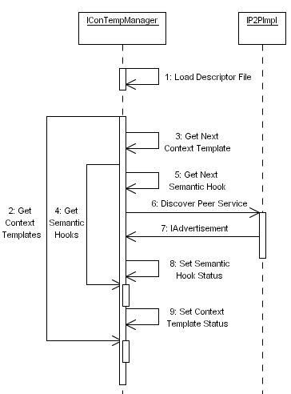
Figure 10 Realise Context Templates

Issues
The issues associated with the Sequence Diagram are not known at this stage.

Assumptions
The assumptions for this Sequence Diagram are not known at this stage of the design

Scenario/Steps
Devices may support zero or more Context Templates that guides dynamic service composition. The Context Template Manager loads each of the context templates supported by a device and tries to discover and bind services to all the semantic hooks contained in a particular context template. When a semantic hook is retrieved the service request used to describe the candidate service required is propagated locally and remotely within the P2P network. This will result in zero or more advertisements being returned to the Context Template Manager. If at least one advertisement is received then the semantic hook status is set to true to indicate that a candidate service has been found. If there is more than one advertisement received then all the services are associated with the semantic hook. When all the semantic hooks within a context template have been bound the context template status must be set to true indicating that the context template can be used.

Extensions
No extensions to the details defined above are known at this stage.

Sequence Diagram: Discover Peer Services

Description
This Sequence Diagram illustrates how Peer Services are discovered within this framework. The Sequence Diagram is illustrated in Figure 11.
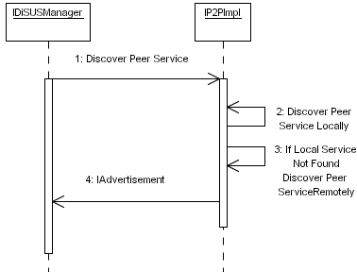
Figure 11 Discover Peer Services

Issues
The issues associated with the Sequence Diagram are not known at this stage.

Assumptions
The assumptions for this Sequence Diagram are not known at this stage of the design

Scenario/Steps
The DiSUS manager discovers Peer Services, whether they be core or application services, using the P2P Implementation. The P2P Implementation object tries to first discover Peer Services locally within the devices advertisement cache. If a Peer Service advertisement cannot be found the P2P Implementation tries to discover the service remotely within the P2P network. Any advertisements that are found are returned to the DiSUS Manager.

Extensions
No extensions to the details defined above are known at this stage.

Sequence Diagram: Invoke Peer Service

Description
This Sequence Diagram illustrates how service requests are matched with service descriptions. The Sequence Diagram is illustrated in Figure 12.
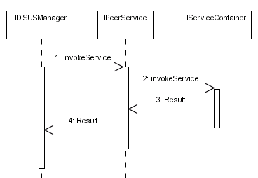
Figure 12 Invoke Peer Service

Issues
The issues associated with the Sequence Diagram are not known at this stage.

Assumptions
The assumption is that implementation services will be used, however this is not a compulsory requirement and device manufacturers are free to implement the functional code within the Peer Service itself.

Scenario/Steps
The DiSUS Manager invokes Peer Services by calling the invokeService method on the Peer Service object. Peer Services within this framework for abstractions to implementation services, which allows any service technology to be used and seamlessly integrated. Consequently a Peer Service will invoke a method on its corresponding implementation services using the Service Container – how this is achieved is dependent on the implementation service technology being used. The Service Container returns the results – if there are any – to the Peer Service, which are in turn returned to the DiSUSManager.

Extensions
No extensions to the details defined above are known at this stage.

Sequence Diagram: Process Service Request

Description
This Sequence Diagram illustrates how service requests are matched with service descriptions. The Sequence Diagram is illustrated in Figure 13.
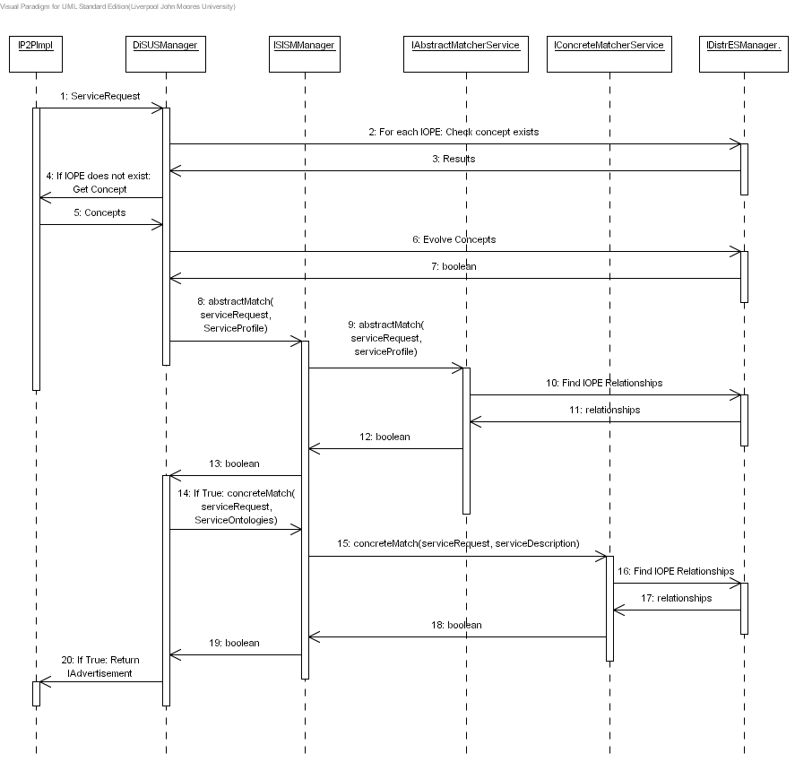
Figure 13 Process Service Request

Issues
The issues associated with the Sequence Diagram are not known at this stage.

Assumptions
The assumptions for this Sequence Diagram are not known at this stage of the design

Scenario/Steps
When a Service Request is received the DiSUS Manager tries to determine if it understands the vocabulary used to describe the IOPEs. For each IOPE in the Service Request it checks to see if the device’s DistrES Service contains knowledge structures that describe the IOPE. If the term is not known then the term is propagated within the P2P network using the P2P implementation, which requests knowledge structures from other devices that describe the term. This will result in zero or more concepts being returned. If the concepts exist the DiSUS Manager evolves the concepts using the DistrES Service to produce an optimal structure that captures the general consensus found within all structures processed. Once the structure has been evolved the DistrES Service will merge it into its existing knowledge structures. This process ensures that the device understands the vocabulary before it begins processing the service request, which is called the Semantic Interoperability Bridge.
The DiSUS Manager begins by trying to match the service request at an abstract level with service descriptions the device has for each Peer Service it provides. This is achieved using the Abstract Matcher Service – here the service request IOPEs are matched with the IOPEs described in a Service Profile or a particular service. The DistrES advertisement is passed to the Abstract Matcher Service, which allows any vocabulary differences to be resolved – for example the service request may refer to an IOPE as “Movie”, whilst the service description may define the IOPE as “Film”. The DistrES Service will allows the two terms to be semantically related allowing the Abstract Matcher Service to conclude that the two terms are equivalent.
If an abstract match is found the Service Ontologies are passed to the Concrete Matcher Service to determine if the IOPEs in the Service Request can be mapped onto signatures described in the Service Interface. If a concrete match is found the service advertisement for the matching service is returned to the service requester.

Extensions
No extensions to the details defined above are known at this stage.

Sequence Diagram: Get Concept

Description
This Sequence Diagram illustrates what happens when a concept is retrieved from the DistrES Ontology. The Sequence Diagram is illustrated in Figure 14.
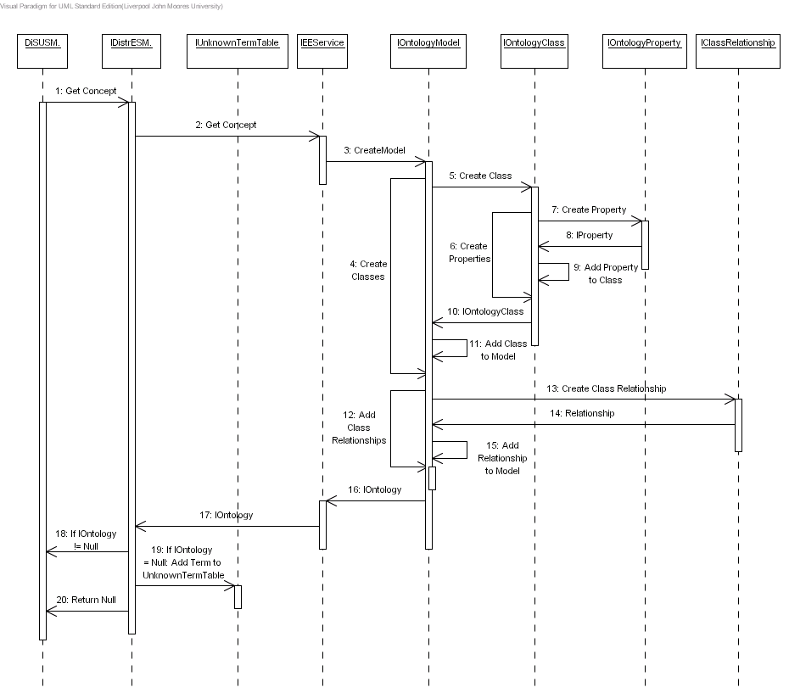
Figure 14 Get Concept

Issues
The issues associated with the Sequence Diagram are not known at this stage.

Assumptions
The assumptions for this Sequence Diagram are not known at this stage of the design

Scenario/Steps
When a device does not know the concept of a term it will formulate a concept request and propagate it within the P2P network. This process in effect is asking if any device within the network understands what a particular term means. Devices that support a DistrES Service will process such messages. In this instance the DiSUS Manager passes the term to the DistrES Manager, which in turn invokes its Extraction Engine Service. If the concept exists the Extraction Engine Service begins by creating an Ontology Model and begins adding all the required classes and their associated properties. When all the classes have been created all the relationships between classes are then added. This ontology model is then returned to DistrES Service. If the model is not null then it is returned to the DiSUS Manager. If the ontology model is null this means that the device does not understand the term and as such adds the term to the Unknown Term Table so that the term can be discovered at some specified point in time. In this instance a null value is returned to the DiSUS Manager – when a null value is received the DiSUS Manager will just drop the concept request.

Extensions
No extensions to the details defined above are known at this stage.

Sequence Diagram: Evolve Concept

Description
This Sequence Diagram illustrates what happens when a concept is evolved and merged into the DistrES Ontology. The Sequence Diagram is illustrated in Figure 15.
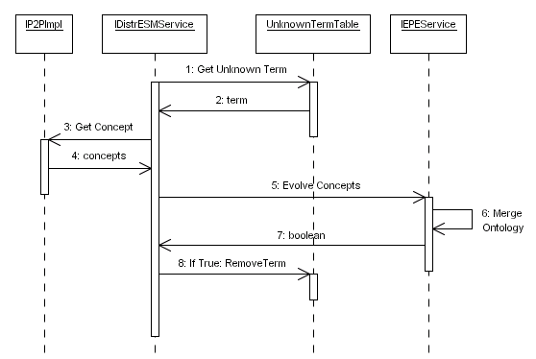
Figure 15 Evolve Concept

Issues
The issues associated with the Sequence Diagram are not known at this stage.

Requirements
Need to do

Goals/Context
Within this Sequence Diagram there are a number of goals that need to be addressed, which are described below.
- Title: Need to do

Assumptions
The assumptions for this Sequence Diagram are not known at this stage of the design

Scenario/Steps
Need to do

Extensions
Need to do

Sequence Diagram: Perform Abstract Match

Description
This Sequence Diagram illustrates what happens when a concept is evolved and merged into the DistrES Ontology. The Sequence Diagram is illustrated in Figure 16.
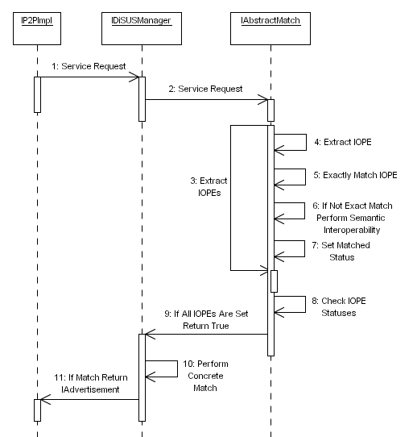
Figure 16 Perform Abstract Match

Issues
The issues associated with the Sequence Diagram are not known at this stage.

Requirements
Need to do

Goals/Context
Within this Sequence Diagram there are a number of goals that need to be addressed, which are described below.
- Title: Need to do

Assumptions
The assumptions for this Sequence Diagram are not known at this stage of the design

Scenario/Steps
Need to do

Extensions
Need to do

Sequence Diagram: Perform Concrete Match

Description
This Sequence Diagram illustrates what happens when a concept is evolved and merged into the DistrES Ontology. The Sequence Diagram is illustrated in Figure 17.
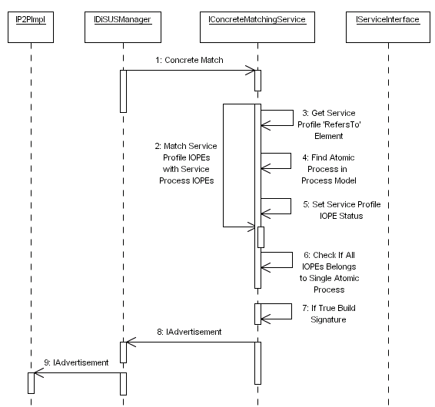
Figure 17 Perform Concrete Match

Issues
The issues associated with the Sequence Diagram are not known at this stage.

Requirements
Need to do

Goals/Context
Within this Sequence Diagram there are a number of goals that need to be addressed, which are described below.
- Title: Need to do

Assumptions
The assumptions for this Sequence Diagram are not known at this stage of the design

Scenario/Steps
Need to do

Extensions
Need to do

Sequence Diagram: Build Signature

Description
This Sequence Diagram illustrates what happens when a concept is evolved and merged into the DistrES Ontology. The Sequence Diagram is illustrated in Figure 18.
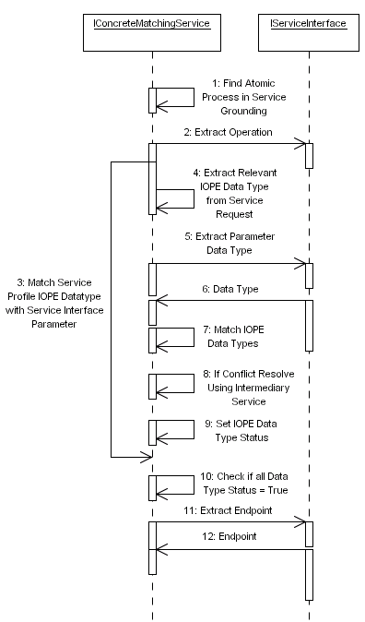
Figure 18 Build Signature

Issues
The issues associated with the Sequence Diagram are not known at this stage.

Requirements
Need to do

Goals/Context
Within this Sequence Diagram there are a number of goals that need to be addressed, which are described below.
- Title: Need to do

Assumptions
The assumptions for this Sequence Diagram are not known at this stage of the design

Scenario/Steps
Need to do

Extensions
Need to do

Sequence Diagram: Find Intermediary Service

Description
This Sequence Diagram illustrates what happens when a concept is evolved and merged into the DistrES Ontology. The Sequence Diagram is illustrated in Figure 19.
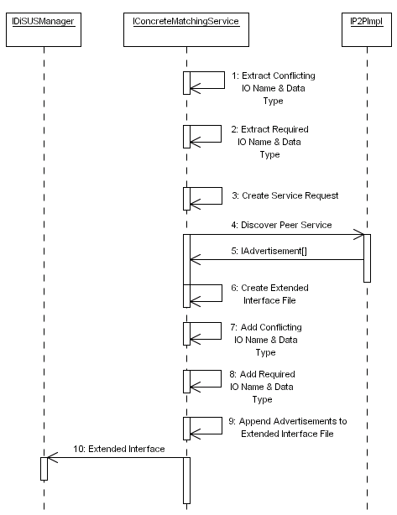
Figure 19 Find Intermediary Service

Issues
The issues associated with the Sequence Diagram are not known at this stage.

Requirements
Need to do

Goals/Context
Within this Sequence Diagram there are a number of goals that need to be addressed, which are described below.
- Title: Need to do

Assumptions
The assumptions for this Sequence Diagram are not known at this stage of the design

Scenario/Steps
Need to do

Extensions
Need to do

References

